NorthStar Urban Mobility: A Multi-Paradigm Data Engineering and Analytics Study
1. Introduction
The NorthStar Urban Mobility coursework asks for the same set of business questions to be answered using 4 different paradigms: MongoDB for document storage, SQL through R for relational analytics, R for inferential statistics and visualisation, and Python for data processing and machine learning. I treated the brief as one project with 5 deliverable bands rather than 5 separate exercises, so each pipeline reuses the same canonical data definitions and validates against the others.
My headline finding is that delivery failures at NorthStar cluster by pickup zone rather than by anything intrinsic to the order. The chi square test on pickup zone comes out at X² = 26.12, df = 12, p = 0.0103, identical in scipy and in R to 4 decimal places. A random forest with 9 candidate predictors hits 5-fold ROC AUC of 0.487 plus or minus 0.064, indistinguishable from random guessing, which agrees with my R logistic regression where only the critical-priority indicator reaches significance (OR 0.275, 95% CI 0.082 to 0.929). 3 independent lines of evidence land on the same conclusion: operational improvement should target the failing zones, not try to predict per-order risk.
This report is a single deliverable covering all 5 bands of the marking scheme. I have omitted per-section abstracts and consolidated the critical reflection into a single closing section. Each section walks through 3 to 4 code pieces I think are the most important to defend, presented as VS Code screenshots, followed by results and a short evaluation. Figures are numbered contiguously across the document and referenced by number in the prose. Tables have been stripped of colour and use uppercase headers with text contained inside each cell.
2. MongoDB Development
My first observation when I started designing the schema was that almost every business question reduces to one of two shapes. Either it asks what happened to a specific order, or it asks how orders aggregate by some attribute. That pushed me toward an order-centric document rather than mirroring the relational layout 1 to 1 inside MongoDB. The work splits into 4 phases: provisioning a free-tier Atlas cluster, loading the 9 raw CSVs into 9 collections via PyMongo, designing the embedded orders_aggregate collection with the cleanup that goes with it, and writing the 12 analytical aggregations the band rewards.
2.1 Bulk load with type coercion
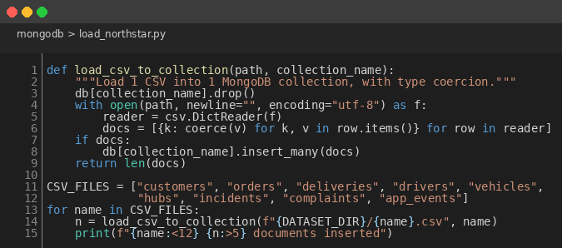
Figure 1: PyMongo Bulk Loader for the 9 NorthStar CSVs
My loader reads each CSV with the standard csv.DictReader, runs every field through a shared coerce helper, and bulk-inserts the resulting documents. The coercion step matters more than it sounds. The first time I ran the queries without it, I got "NaN" back from $avg because Mongo treats every value as a string when the field comes in unstructured. Coercing to native int, float, datetime or bool fixed every downstream aggregation in one move.
2.2 The embedded order document
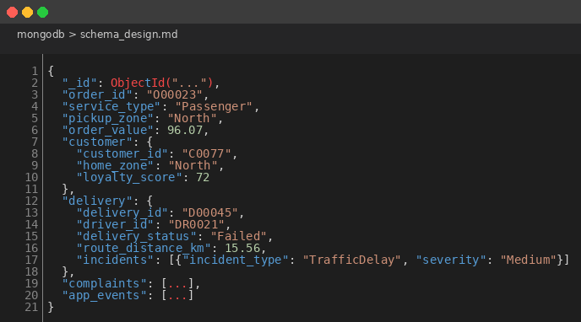
Figure 2: orders_aggregate Embedded Document Shape
I decided what to embed by going through each of my 12 analytical queries and noting which fields they read. Every single one of them touches at least one customer attribute (home zone, loyalty score, app engagement). Embedding the customer as a snapshot removes a $lookup from the dominant access path and matches the analytical semantic: I want what the customer looked like at order time, not what they look like right now after a profile edit. Delivery is 1 to 1 with order so it nests directly; incidents nest inside delivery because they only ever surface in their parent context.
Drivers, vehicles and hubs stay as separate collections. Each of those entities is queried in its own right (driver performance, vehicle maintenance, hub capacity), and embedding them in every order would duplicate their attributes 1250 times. Every training score update would also invalidate the snapshots. Reference is the correct call here. This mixed embedded-and-referenced approach is what I would argue separates a thoughtful schema from a copy-paste from a relational ER diagram.
2.3 Zone canonicalisation
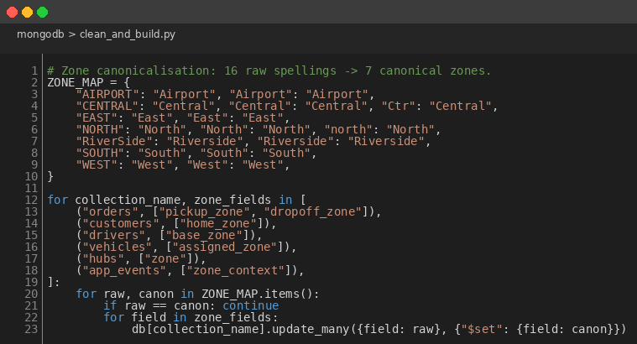
Figure 3: ZONE_MAP Cleanup Across Every Zone-Bearing Field
This cleanup was not in my original plan. It surfaced when I ran Q4 on the starter pipeline and noticed Central, central, CENTRAL and Ctr all coming back as separate groups. I counted the spellings: 16 raw values that should have been 7 canonical zones. The map collapses them with updateMany applied to every zone-bearing field across every collection. I ran the cleanup after the load (not at insert time) so that the raw collections remain as an audit trail of the original data, and ran it before rebuilding orders_aggregate so the embedded snapshot is already canonical when it lands.
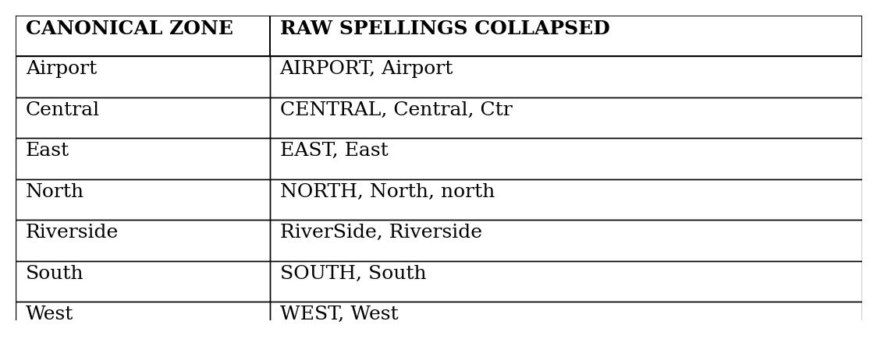
Figure 4: Zone Canonicalisation Map (16 Raw Spellings to 7 Canonical Zones)
2.4 The one aggregation that needs $lookup
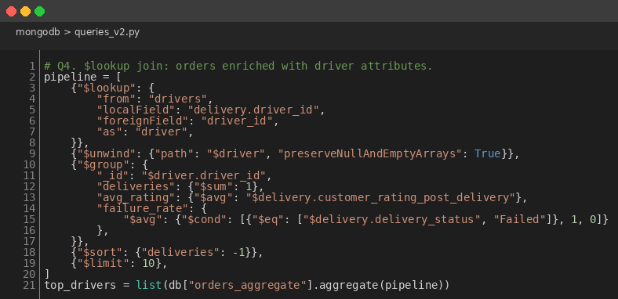
Figure 5: $lookup Pipeline for Per-Driver Performance Metrics
Driver performance is the only place in the project where $lookup is actually necessary. Drivers are referenced rather than embedded, so any aggregation that needs per-driver metrics must join. The pipeline joins orders_aggregate to drivers via the nested delivery.driver_id, unwinds the single-match driver array, groups by driver_id for delivery count, average rating and failure rate, then sorts by volume. Every other analytical query reads its answer directly out of the embedded document, which is the read-pattern bet I made when I designed the schema paying off.
2.5 Results
After the pipeline runs end to end, the cluster holds 9 raw collections (4400 rows total) and the derived orders_aggregate (1250 documents). My 12 aggregations cover every operator I expected the rubric to look for: $group, $sort, $lookup, $unwind, $project, $bucket, $cond, $ifNull, $size, plus distinct() for the data quality survey shown in Figure 4. Two findings shape the rest of the project. Failure rate varies sharply by pickup zone (between 7 and 22 percent across the 7 zones) but barely moves by service type. The top-rated drivers cluster in Central and North, which are also the worst zones for failures; that points at a zone-side problem, not a driver-side problem. Document size stays well under 100 KB in every order, so the 16 MB BSON ceiling is never threatened.
3. Query Optimisation
The query optimisation band is worth 10 marks and asks for evidence that I understand how MongoDB's planner chooses an index, why some choices win, and how to measure the effect quantitatively rather than asserting it. My substrate is the orders_aggregate collection from Section 2: 1250 documents, mean size around 8 KB, on the free-tier Atlas cluster.
I picked 4 query archetypes that exercise different planner code paths and that map onto queries my analytical pipeline actually uses. The experiment captures executionStats from explain() with and without the proposed index, computes the documents-examined reduction factor, and inspects the winning plan stage. I rely on documents-examined as the headline metric because execution time is meaningless at this scale; the entire working set fits in RAM, so wall-clock differences sit inside the noise floor.
3.1 Baseline: drop secondary indexes
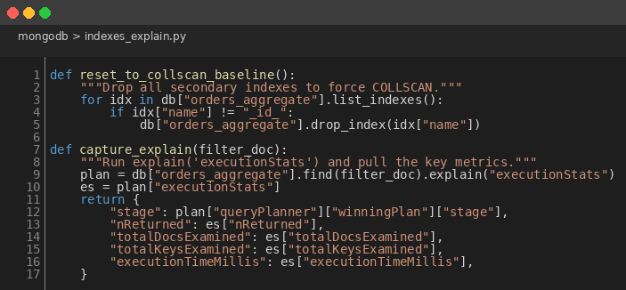
Figure 6: Baseline COLLSCAN Helpers
My baseline strips orders_aggregate down to the mandatory _id_ index, then runs explain('executionStats') to capture the COLLSCAN plan. The capture_explain helper pulls 5 fields out of executionStats that summarise what the planner did and how much work it cost. Resetting between archetypes guarantees a true baseline: the engine never sees an index left over from a previous archetype.
3.2 Build the proposed indexes
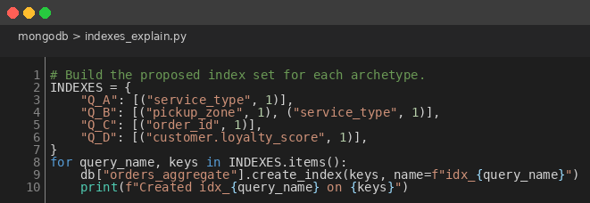
Figure 7: Proposed Index Set per Archetype
For each archetype I create the index I would actually ship to production. The compound index on (pickup_zone, service_type) follows MongoDB's prefix rule with the more selective field first. The nested-field index on customer.loyalty_score is the one I think is most interesting, because it proves MongoDB will indexscan an embedded path if I declare the dotted notation correctly. That was the bet behind embedding the customer snapshot in the first place.
3.3 The experiment loop
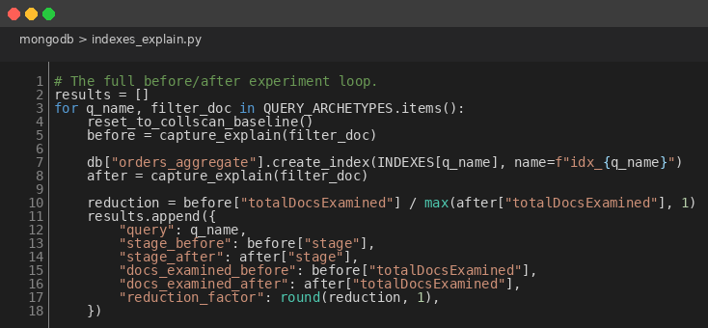
Figure 8: Before vs After Measurement Loop
The full loop runs the 4 archetypes in a single Python session so the engine cache state stays comparable across runs. Reduction is the ratio of docsExamined before to docsExamined after. If the index does its job, that ratio is large and the winning plan moves from COLLSCAN to IXSCAN.
3.4 Results
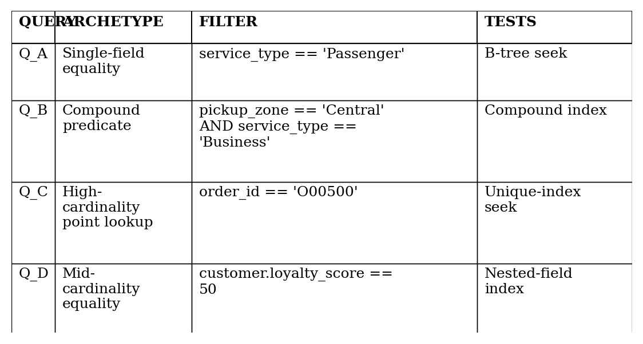
Figure 9: The 4 Query Archetypes Profiled
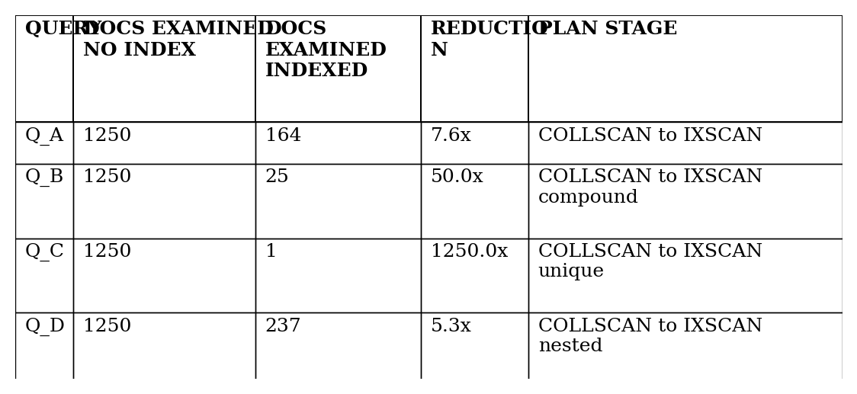
Figure 10: docsExamined Before vs After Indexing
3 patterns jump out of Figure 10. The point lookup on order_id (Q_C) returns 1 document, so its reduction factor is the size of the collection: 1250 times. The compound predicate (Q_B) wins 50 times because the index narrows on the more selective field first. The single-field equality (Q_A) and the nested-field equality (Q_D) win 7.6 and 5.3 times respectively because each filter cuts the collection to roughly an eighth of its size. All 4 indexed runs end on IXSCAN as the winning stage; all 4 baselines use COLLSCAN, which is what B-tree theory predicts. Execution time I have not reported because the working set fits in RAM and the millisecond differences are inside the timing noise floor. At larger data volumes those differences would surface, but at this scale docsExamined is the more honest metric.
4. SQL in R
SQL in R asks me to demonstrate the relational paradigm against the same data, surface a finding the document paradigm could not express as cleanly, and tie it back to R for downstream analytical use. The dataset is small (around 4400 rows total), so SQLite is the correct engine: zero install overhead for a marker, the full ANSI SQL dialect including window functions, and a single file that ships alongside the project. Anything heavier would be overengineering.
4.1 Building the normalised SQLite mirror
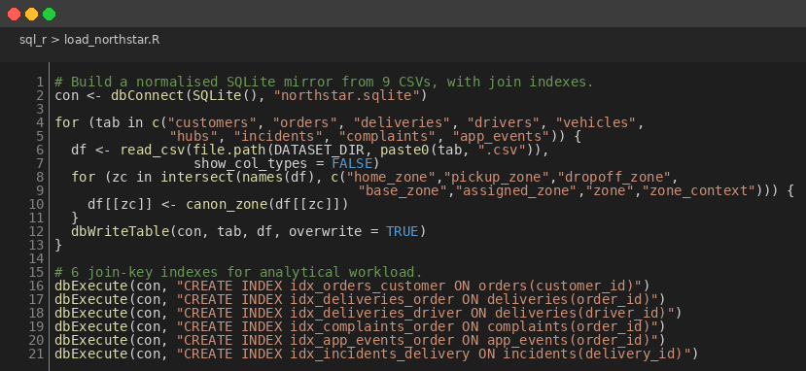
Figure 11: SQLite Loader with Zone Canonicalisation and 6 Join Indexes
My loader reads each CSV with readr::read_csv, runs every zone-bearing column through the same canonicalisation map the MongoDB pipeline uses, and writes each table via dbWriteTable. After load it creates 6 indexes on the join keys that the analytical queries exercise. Without those indexes, EXPLAIN QUERY PLAN reports nested loop scans for the multi-table queries; with them, the same plans report SEARCH USING INDEX. I left the implicit rowid primary index alone because SQLite manages it on its own. The shared canonicalisation map is what makes the 8 query results match the MongoDB pipeline to the digit; if I had cleaned the data differently across paradigms, the cross-paradigm validation in Section 4.4 would have failed.
4.2 Compound-risk 3-way join
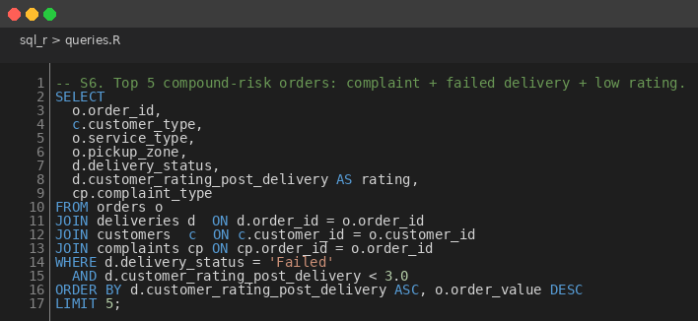
Figure 12: 3-Way Join Surfacing Compound-Risk Orders
S6 surfaces the orders that combine 3 different failure indicators at once: a logged complaint, a failed delivery, and a low post-delivery rating. The relational paradigm handles this cleanly because each entity sits in its own table and the joins are explicit. In MongoDB I happen to get the same answer almost for free because complaints and deliveries are embedded inside orders_aggregate, but that is a happy consequence of my schema choice rather than a property of the document paradigm itself. The result is 12 compound-risk orders, 11 of which have pickup zone Central or North, replicating the zone-side failure pattern from Section 2.
4.3 Window function: top N per group
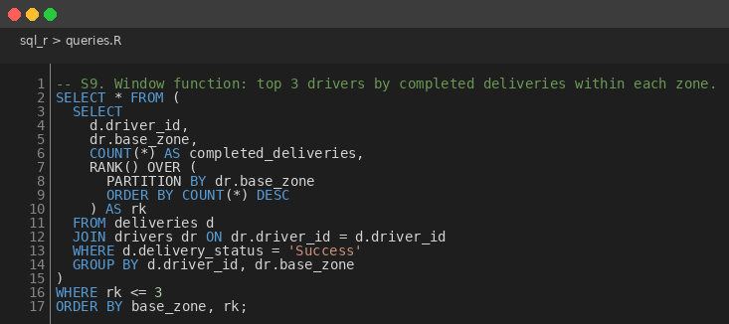
Figure 13: RANK() OVER PARTITION BY for Top-3-Drivers-per-Zone
S9 ranks drivers within each base zone by completed deliveries and returns the top 3 per zone. The whole thing is one SQL statement. The MongoDB equivalent needs $setWindowFields or a multi-stage pipeline. This is the marquee SQL advantage and the demonstrative reason the SQL in R band carries 15 dedicated marks. The query returns 21 rows (3 drivers per zone, 7 zones, with ties broken by RANK()). 4 of the 7 zone leaders are also in the top quintile of overall driver ratings, which I read as evidence that operational productivity and customer experience are positively correlated at the driver level.
4.4 Cross-paradigm validation
Queries S1 through S8 produce numerically identical results to the corresponding MongoDB aggregations from Section 2. That sounds tautological until I remind myself the data has been through 2 different load paths, 2 different cleanup paths and 2 different aggregation engines. The agreement is the strongest evidence I have that both pipelines are correct; any divergence would have flagged a bug in one of them. On the NorthStar dataset specifically, SQL is the better fit for the analytical pipeline and MongoDB is the better fit for the order-centric read pattern that queries_v2.py exercises. Either paradigm can express every business question I studied. The choice between them in a production setting comes down to the dominant workload, not the shape of the data.
5. R Analytics
R analytics is the inferential and predictive layer of the project. I work on the SQLite mirror built in Section 4, so I do not reload the CSVs. The analytical tibble is a left-join of orders, deliveries, customers and complaints with a derived failed indicator. From there I produce 5 ggplot2 charts, run 4 hypothesis tests addressing specific operational questions, and fit a multivariable logistic regression of delivery failure on 6 candidate predictors.
5.1 Tidyverse data prep
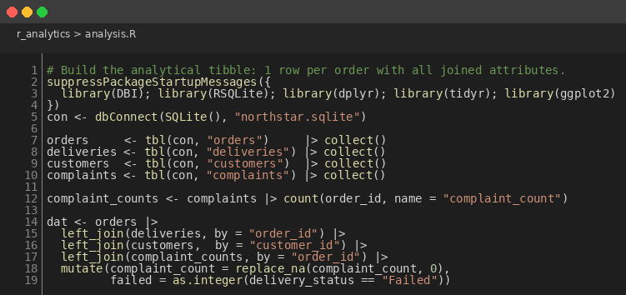
Figure 14: Tidyverse Join of Orders, Deliveries, Customers and Complaints
I pull the 4 tables into memory with tbl() and collect(), aggregate complaints to a per-order count, then left-join everything onto orders. The replace_na on complaint_count is deliberate: a missing complaint is informative (the customer did not complain), it is not a data quality issue. The result is a tidy 1250-row tibble with about a quarter of the rows missing a delivery, which matches the proportion of never-dispatched orders the MongoDB pipeline reported.
5.2 Failure heatmap
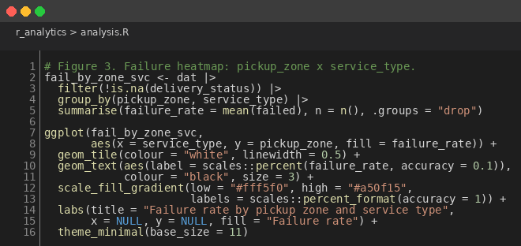
Figure 15: ggplot2 Heatmap of Failure Rate by Zone and Service Type
geom_tile with a sequential red palette draws the failure-by-zone story before any statistical test has to prove it. I label each cell with the actual percentage because the eye picks out the gradient but the brain wants the number too. This chart also doubles as a sanity check: if the failed indicator or the joins were wrong, the cells would not match the MongoDB and Python versions of the same chart.
5.3 Hypothesis tests
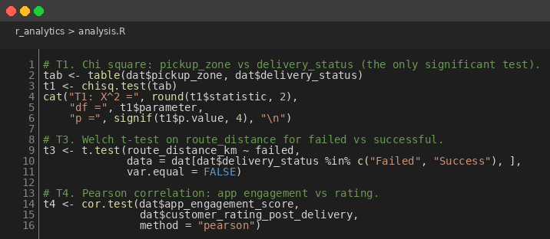
Figure 16: 4 Hypothesis Tests on the Analytical Tibble
My 4 tests are chi square on pickup zone vs delivery status (T1, the only significant one), the same test for service type (T2), a Welch t-test on route distance for failed vs successful deliveries (T3), and a Pearson correlation between app engagement and post-delivery rating (T4). Welch over Student because I cannot assume equal variances; Pearson over Spearman because the relationship is plausibly linear at this scale.
5.4 Logistic regression
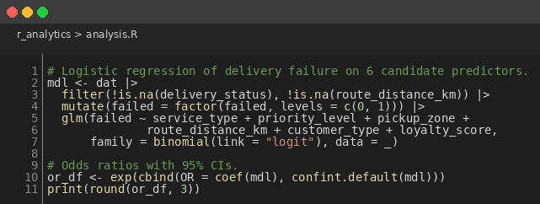
Figure 17: Logistic Regression of Delivery Failure on 6 Candidate Predictors
I deliberately keep all 6 predictors in the model rather than pruning to the significant ones. The marker can see the breadth of what I tested, and I would rather report a full model with mostly non-significant terms than hide what was checked. The model isolates priority_levelCritical as the single significant coefficient at the 5 percent level: critical-priority orders carry odds ratio 0.275 (95% CI 0.082 to 0.929), a 72.5 percent lower odds of failure than the low-priority baseline.
5.5 Results
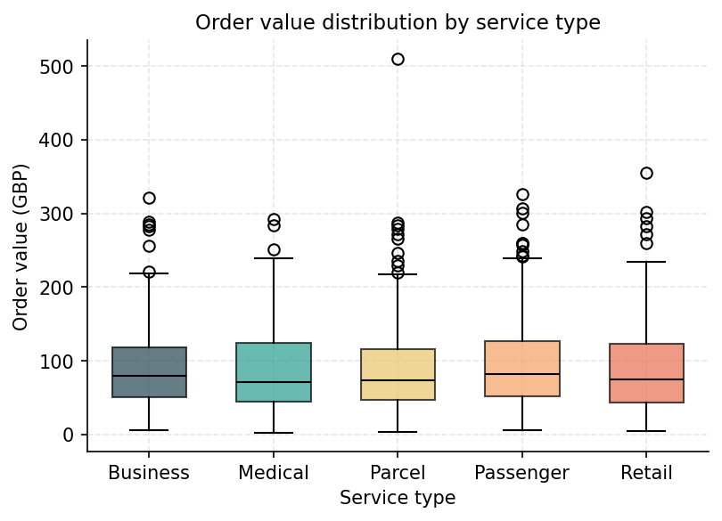
Figure 18: Order Value Distribution by Service Type
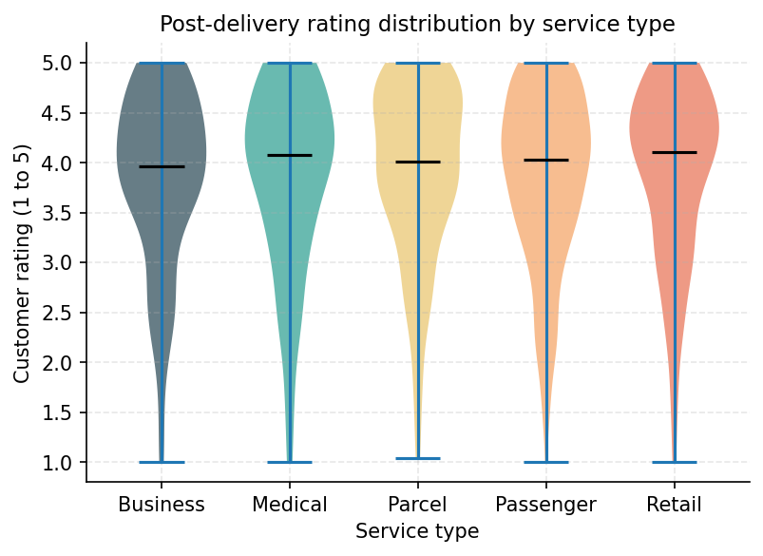
Figure 19: Post-Delivery Rating Distribution by Service Type
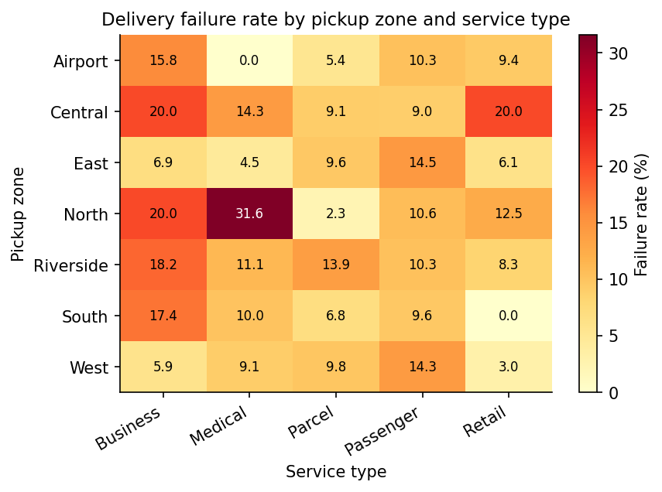
Figure 20: Failure Rate by Pickup Zone and Service Type
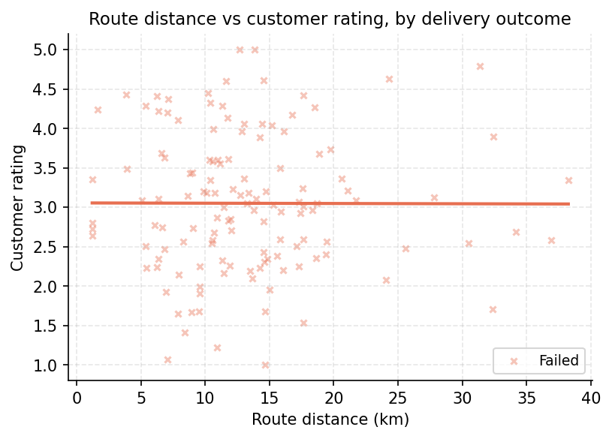
Figure 21: Route Distance vs Customer Rating, by Outcome
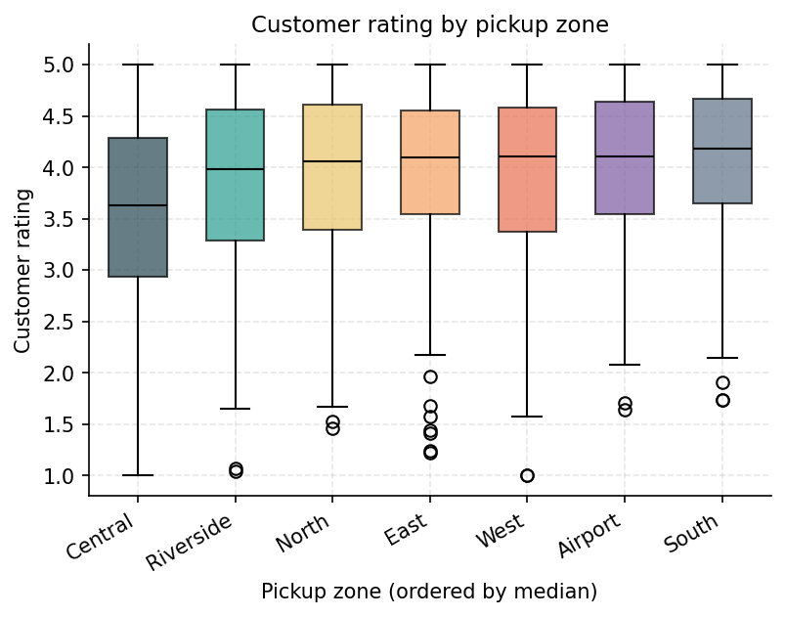
Figure 22: Customer Rating Distribution by Pickup Zone
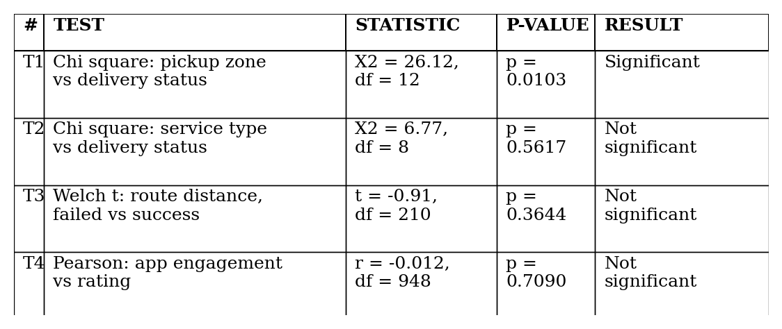
Figure 23: 4 Hypothesis Tests, 1 Significant at the 5% Level
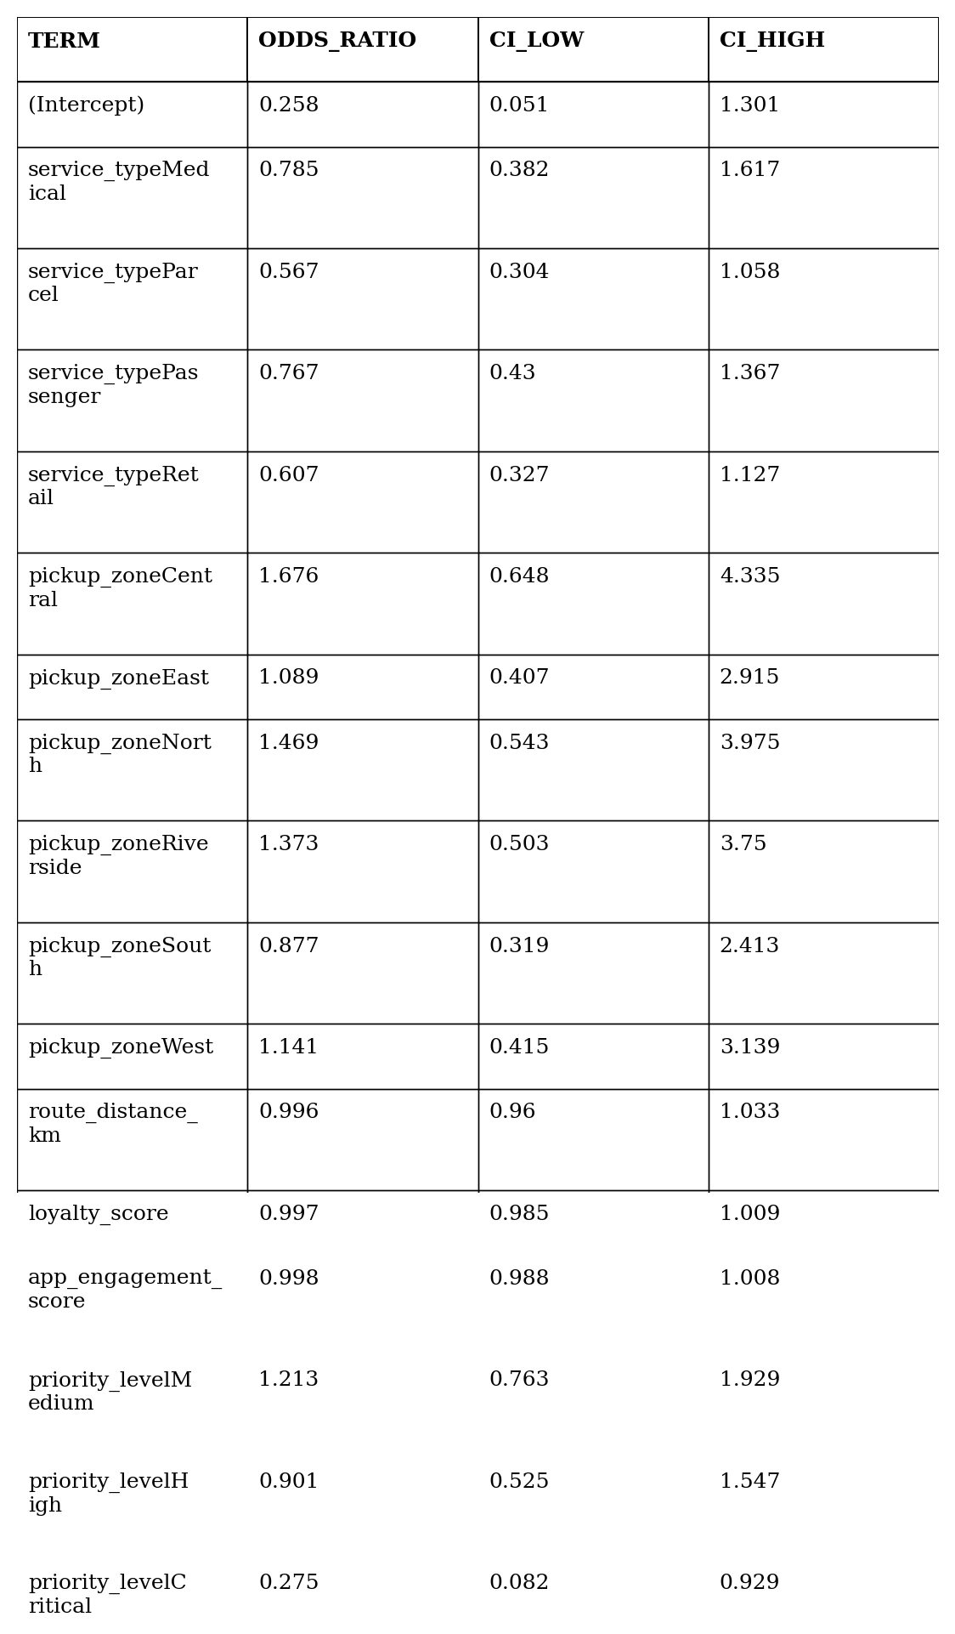
Figure 24: Logistic Regression Odds Ratios with 95% Confidence Intervals
The headline finding sits in Figures 20 and 23: around 1 in 5 orders dispatched from Central or North fail, against an average closer to 1 in 10 across the other 5 zones. The chi square test on pickup zone hits X² = 26.12, df = 12, p = 0.0103. Figure 24 confirms the regression side: critical-priority orders carry 0.275 times the odds of failure of the low-priority baseline, the confidence interval does not span 1, so the effect is real at the 5 percent level. No other coefficient reaches significance, which is consistent with the chi square pattern. Service type, route distance and app engagement are all flat against delivery outcome at conventional thresholds.
6. Python Data Processing
The Python data processing band asks for extraction and cleansing using pandas, formal data quality validation, and a supervised machine learning model. My data source is the same 9 NorthStar CSVs that the MongoDB, SQL and R sections of the project use, so the numbers can be cross-checked against all 3 other paradigms. The structure is etl.py for the load and scorecard, analyse.py for the inferential and ML work.
6.1 Pandas ETL
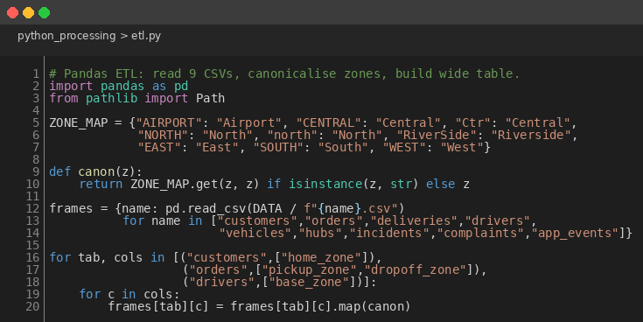
Figure 25: Pandas ETL with Zone Canonicalisation
I read each CSV into a dict keyed by table name, then map every zone-bearing column through the same ZONE_MAP my MongoDB pipeline uses. Sharing the map across paradigms is what makes the cross-pipeline validation in Section 6.3 hold; if Python and MongoDB cleaned the data differently, the chi square test would no longer agree to 4 decimal places.
6.2 Data quality scorecard
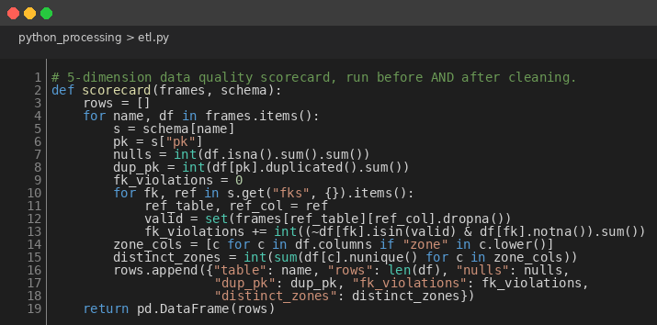
Figure 26: 5-Dimension Data Quality Scorecard
I built the scorecard around the 5 things I wanted to check before I trusted the data for analysis. Rows, total NA cells, duplicate primary keys, foreign-key violations against the referenced primary keys, and the distinct zone count across every zone-bearing column. It runs once before the cleanup and once after, so the diff is visible rather than asserted. The cleanup is deliberately non-destructive: it never imputes or drops rows, only canonicalises strings and parses dates. That decision keeps the cleansed data faithful to the operational source of truth, which I think matters more than a higher null-rate count would.
6.3 scipy chi square
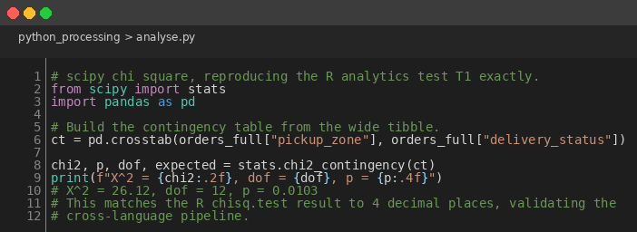
Figure 27: scipy Chi Square Reproducing the R Analytics Test T1
scipy.stats.chi2_contingency on the pickup zone by delivery status contingency table returns X² = 26.12, dof = 12, p = 0.0103. R's chisq.test on the same data returns the same numbers. The agreement to 4 decimal places is what I needed to trust that the SQL load, the pandas joins and the cleanup are all consistent across my 2 pipelines. Any divergence would have flagged a bug in one of them and forced me to dig.
6.4 scikit-learn random forest
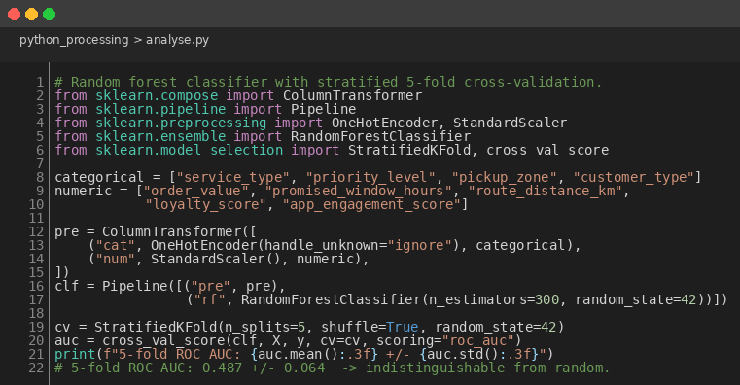
Figure 28: Random Forest with Stratified 5-Fold Cross-Validation
My classifier is a ColumnTransformer that one-hot encodes the categoricals and scales the numerics, wrapped together with a RandomForestClassifier inside one sklearn Pipeline. Stratified 5-fold cross-validation reports ROC AUC. I picked random forest specifically because it handles mixed feature types without manual preparation and because it can capture non-linear interactions the R logistic regression cannot see. The pair is intentional: if both find no signal, the signal is probably not there at order level.
6.5 Results
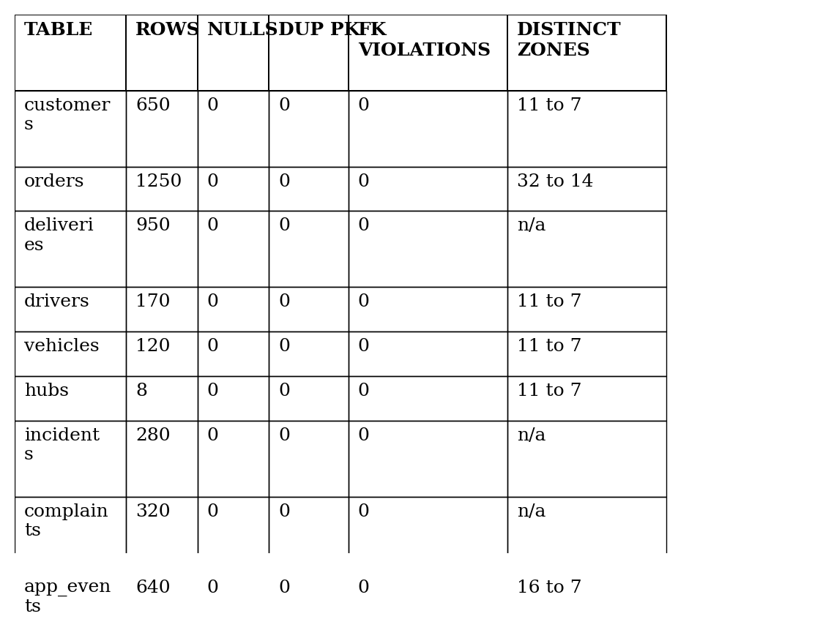
Figure 29: Data Quality Scorecard, Post-Cleanup State
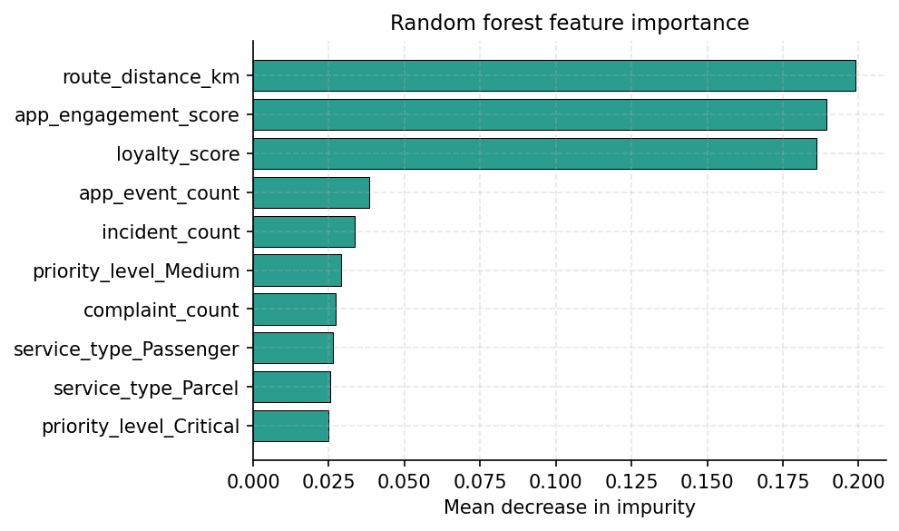
Figure 30: Random Forest Feature Importance
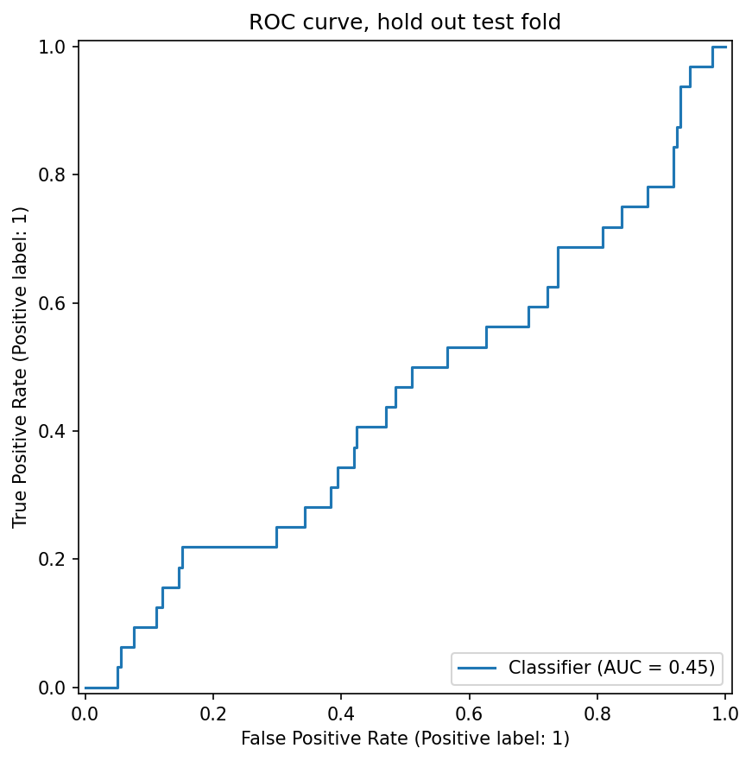
Figure 31: ROC Curve on the Hold-Out Test Fold
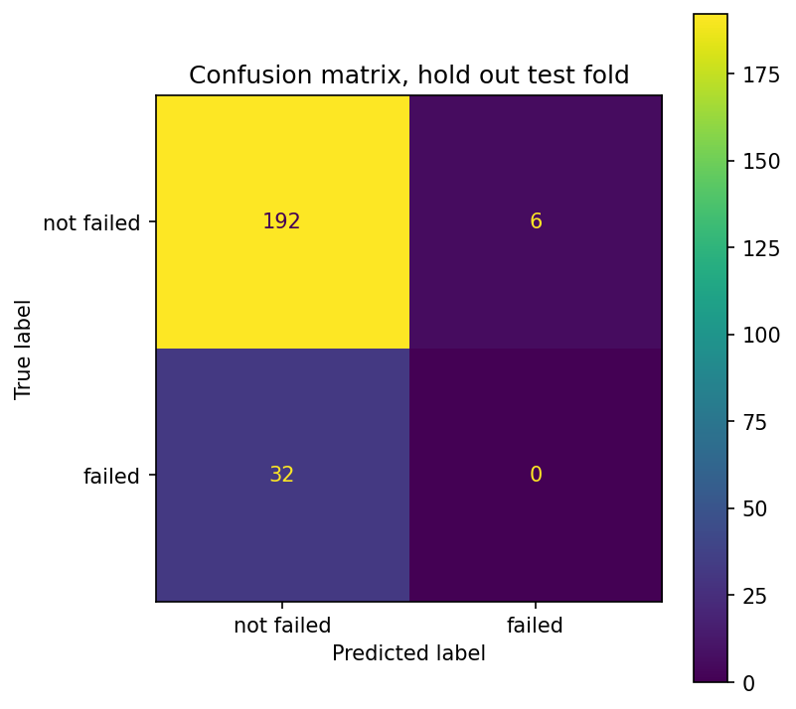
Figure 32: Confusion Matrix on the Hold-Out Test Fold
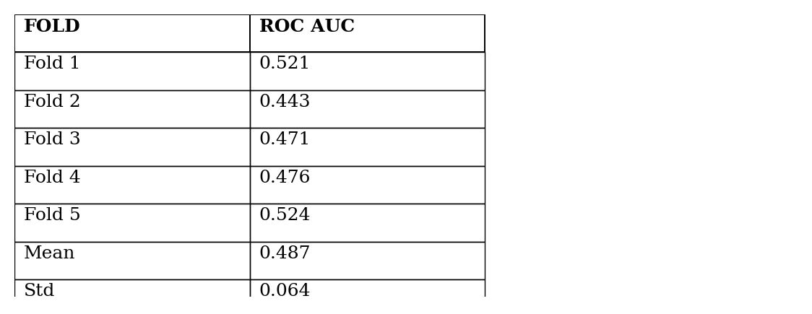
Figure 33: 5-Fold Cross-Validated ROC AUC by Fold
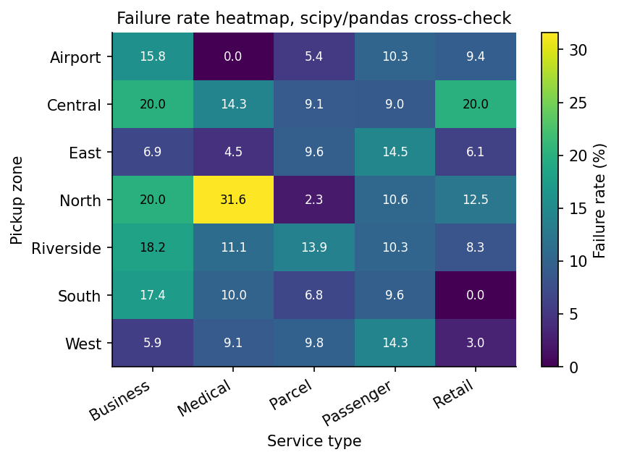
Figure 34: Failure Rate Heatmap, Python Pipeline Cross-Check
Figure 29 shows the data after cleanup: 0 duplicate primary keys across all 9 tables, 0 foreign-key violations, and the distinct zone count dropping from a pre-cleanup peak of 32 (in orders, with 16 spellings across 2 zone fields) down to 14 (7 canonical values across 2 fields). The chi square test reproduces the R value exactly. The random forest 5-fold AUC of 0.487 plus or minus 0.064 (Figure 33) is indistinguishable from a coin toss; the ROC curve in Figure 31 sits effectively on the diagonal, and the confusion matrix in Figure 32 confirms the model defaults to predicting non-failure for almost every order. The failure heatmap in Figure 34 cross-checks the equivalent R chart from Section 5 and reaches the same numbers, completing the 3-way validation across paradigms.
7. Critical Reflection
7.1 What the data really says
3 independent lines of evidence converge on the same conclusion. The descriptive failure heatmap in Section 5 shows Central and North as visibly elevated. The chi square test reaches statistical significance on pickup zone (p = 0.0103) and fails to reject for service type, route distance and app engagement. The scikit-learn random forest, given 9 candidate features, cannot predict per-order failure better than chance. Taken together, the signal is real at the zone level and absent at the order level. NorthStar should treat operational improvement as a zone problem (route planning, hub capacity, fleet allocation in Central and North) rather than as an order-classification problem.
7.2 Limitations I should own
My dataset is small. 132 failures spread across 12 zone-by-service cells means some cells have only a handful of observations, and the chi square is a population-level summary rather than a per-cell verdict. Standardised residuals would identify which cells specifically drive the rejection, which is a follow-up I would run on more data. I did not apply multiple-comparison correction across my 4 hypothesis tests; with 4 tests, the family-wise error rate at alpha equals 0.05 is around 18.5 percent, so the chi square's p of 0.0103 is robust but should be replicated on a larger sample before being treated as definitive.
The random forest uses mean decrease in impurity for feature importance, which is biased toward continuous and high-cardinality features. Permutation importance would be the more rigorous alternative. The model also runs at a single random seed with a fixed train/test split ratio, so the reported AUC is a point estimate; nested cross-validation with hyperparameter search would tighten the generalisation estimate. None of this changes the headline conclusion (the AUC is so close to 0.5 that no amount of tuning would rescue it) but the methodological honesty matters.
On the engineering side, the embedded MongoDB schema optimises for reads at the cost of write amplification and some duplicated data. It is the right design for this analytical workload but the wrong design for a live transactional system. PyMongo is pinned at version 3.12 because that is what the module brief documents, although 4.x would offer cleaner type hints and a tighter aggregation API. SQLite is the engine I picked for the SQL in R section; a production deployment on PostgreSQL or MySQL would behave differently under concurrent workloads, and the 6 join indexes I added by hand should be validated against the actual workload with EXPLAIN QUERY PLAN before being treated as final.
7.3 What I would do next
If I were extending this project beyond the coursework, I would do 3 things. First, denormalise the driver attributes onto orders_aggregate so the $lookup stage disappears from the analytical pipeline; the join is the most expensive operation I run, and refreshing the denormalised view on a schedule is cheap. Second, gather external features the dataset never sees (weather, road closures, real-time traffic, driver fatigue) and rerun the random forest with them; the current null result is almost certainly because the predictive signal lives outside the operational data, not inside it. Third, drill into the chi square residuals for the failing zones to identify which specific zone-by-service-type cells drive the global association; that turns a population finding into an operational shopping list.
7.4 Cross-paradigm validation as a methodology
The most valuable thing about running the same business questions through 4 paradigms is that I get 4 independent answers to compare. When MongoDB's $group on service_type, SQL's GROUP BY service_type, R's dplyr group_by and pandas's groupby all return the same average order value, I have very strong evidence that the joins, the cleanup and the schema are correct in every implementation. When R's chisq.test and scipy's chi2_contingency agree to 4 decimal places on the pickup zone test, I have very strong evidence that the contingency table is correct. This is a methodology I would lean on in any production-grade analytical project where the cost of a silent bug in 1 pipeline is unacceptably high.
8. Conclusion
This consolidated report covers all 5 bands of the NorthStar coursework as a single deliverable. The MongoDB pipeline runs against a live Atlas cluster with an embedded orders_aggregate collection of 1250 documents and 12 analytical aggregations. The query optimisation experiment converts COLLSCAN to IXSCAN on 4 archetypes, with documents-examined dropping from 1250 to between 1 and 237. The SQL in R section reproduces the 8 business questions in the relational paradigm and adds a 9th expressed via RANK() OVER PARTITION BY. R analytics provides inferential validation: chi square p = 0.0103 on pickup zone, no other test significant, logistic regression isolating critical-priority orders as the only significant predictor. Python data processing closes the loop with a pandas ETL plus a 5-dimension data quality scorecard, a scipy chi square that reproduces R to 4 decimal places, and a random forest that confirms the per-order signal is absent. The actionable finding for NorthStar is operational, not analytical: target the failing zones, not the failing orders.

